Enabling Women | Educating Children
Annual Report  April 2013- March 2014 |  | 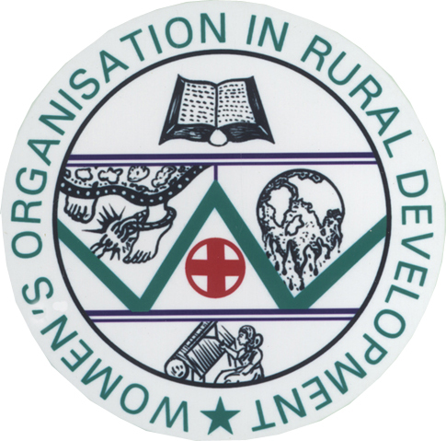
Offering Quality Services for the upliftment rural women and children in Erode, Namakkal and Salem Districts of Tamilnadu, India.
Admin Office:
7-C, Andikadu,
Vediarasampalayam Road,
Agraharam Post,
Pallipalayam. 638 008,
Namakkal District.
Tamilnadu. India.
Phone: 91- 4288- 240 212.
E-mail : mails@wordorg.net
Web: http://www.wordorg.net

Our partners in Development

 | Tamilnadu Corporation for Women Development Ltd,  Chennai.  http://www.tamilnaduwomen.org | Women Development Project.  From August 2002.
 | Terre des Homes - Netherlands.  http://www.tdh.nl | “Blooming Buds Project” – An overall development of children in 40 villages in Namakkal Block.  From October 2008.
 | Terre des Homes - Netherlands.  http://www.tdh.nl | Revolving Fund of Relief of Poor Program.  From December 2010
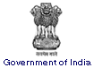  Ministry of Labour and Employment | National Child Labour Project (NCLP),  Government of India.  http://labour.nic.in/cwl/childlabour.htm | Special Schools for Child Labourers.  From November 2004.
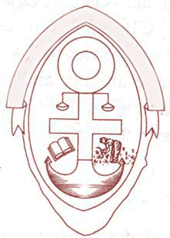 | South Central India Network for Development Alternatives (SCINDeA).  http://www.scindea.org | Integrated Community Development Program.
 | Fair Climate Network, Karnataka  http://www.fairclimate.com | Microscale CDM Biogas Program  From May 2011
Ministry of Women and Child Development | Integrated Child Protection Scheme (ICPS),  Department of Social Defense, Govt of Tamilnadu | Situational Assessment on Child Protection in Namakkal District.
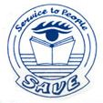 | Social Awareness and Voluntary Education- SAVE/ International Federation of Human Rights- FIDH. | Prevention of Child Workers in Garment Industries from March 2014.

From the Director’s Desk…..
Dear All,  I am extremely happy to meet you all again.  WORD has crossed its twentieth year of its social service and entered in its twenty sixth year with great joy and regained hope. With all the rich experience it has attained in the long path having administered wide range of projects, we do hope to carry the things forward with the learnings blended with new innovations and quality delivery of services to the public.  On behalf of WORD and on my personal behalf, I would like to express my full-hearted thanks and gratitude to all those who have extended their financial, programmatic, organizational and technical guidance to us in the due course of time. Our thanks are due to our individual sponsors and funders to all our program initiatives.  We also thank the support and co-operation from all the government & non-government officials in Namakkal, Salem and Erode Districts, local elected representatives, co-working friends, staff team of WORD, development consultants, auditors, lawyers, philanthropists, media friends, well wishers, volunteers in the public and | people in the local areas who extended their absolute co-operation and support in implementing all our programmes successfully and diligently with people's participation.  Thanks for all the co-operation and expect the same in the future too....  Socially Yours,  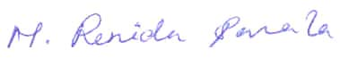  M. Renida Sarala,  Director. sarala@wordorg.net

women development project

With the support from Tamilnadu Women Corporation for Women Development Limited. Chennai through its project implementation Unit at Namakkal under Mahalir Thittam scheme, this program is being implemented in Pallipalayam block of Namakkal District from August 2002.

Under this wide-ranging women empowerment program, the rural women in Pallipalayam area are being organised into women self help groups (SHGs). There are 12-20 members are in a SHG. Till March 2014, 936 groups have been formed with 17226 rural women besides 41 male SHGs.
Each SHG is having their own savings accounts in the nearby banks and they are promoted to practice the internal thrift and credit process. The women group members were being given various intensive training packages including the induction and orientation training on the concept of SHGs, leadership training, Entrepreneurial Development program (EDP), Various Income Generation Programs like production of goods, Marketing strategies, various vocational training programs, value added services to the products etc.,
The groups have started to manufacture their own products. Many groups involved in manufacturing house-hold things, vermi-composting, toys making, bamboo products, garments, embroidery, chrosa works, glass painting, oil painting etc.

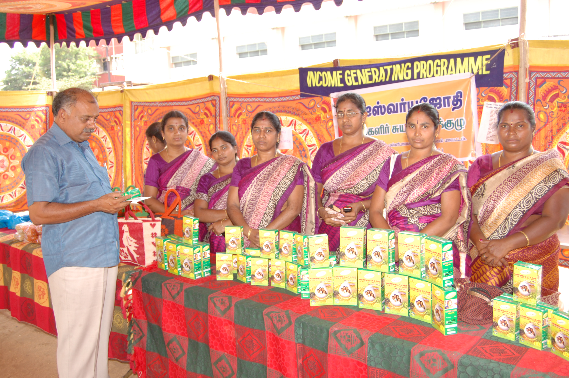 | 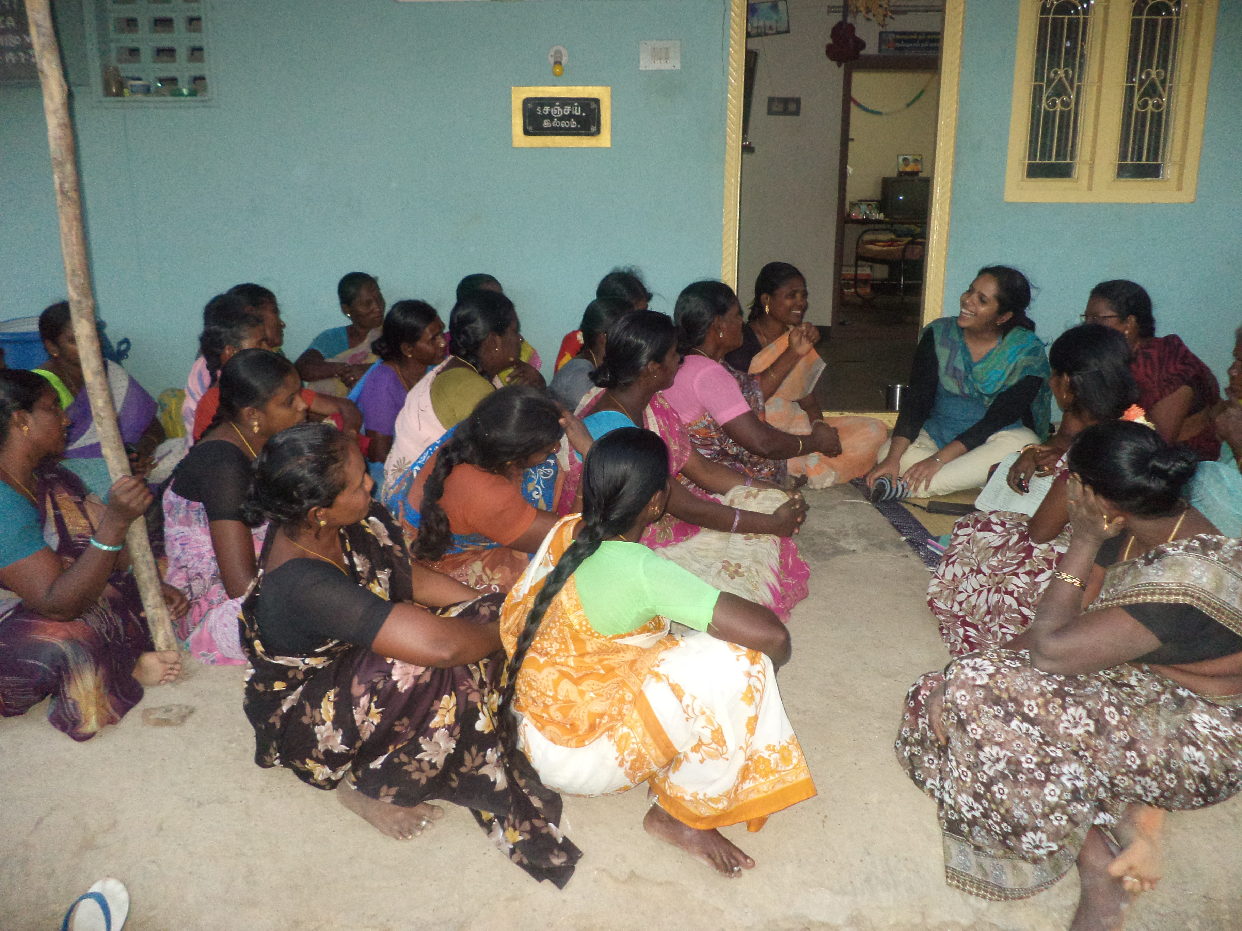

Some groups have engaged in rural computer centres, co-operative milk societies, readymade garment units, vehicular transport services etc.,

The women groups are instrumental in educating rural folk and the improvement of rural economy. Through them we are reaching out the outreached sections of the society. Many women groups are also helping to each other especially to the downtrodden and to those affected and infected with HIV/AIDS.
Till March 2014, the women SHGs have got a loan of Rs 18, 79, 17, 905 from the Banks under various schemes. The best thing is that the integration of the rural women in all the project activities contributes to the overall development of the society.International Women’s Day 2014 was celebrated on 30th March 2014. Various events were conducted on this day including awareness rally, competitions for women’s group members, exhibition of the SHG products etc. The winners were given away prizes. Mr. Thangamani, Minister of Industries, Government of Tamilnadu was the chief-guest of the program.
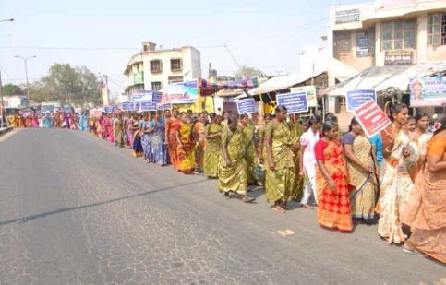 | 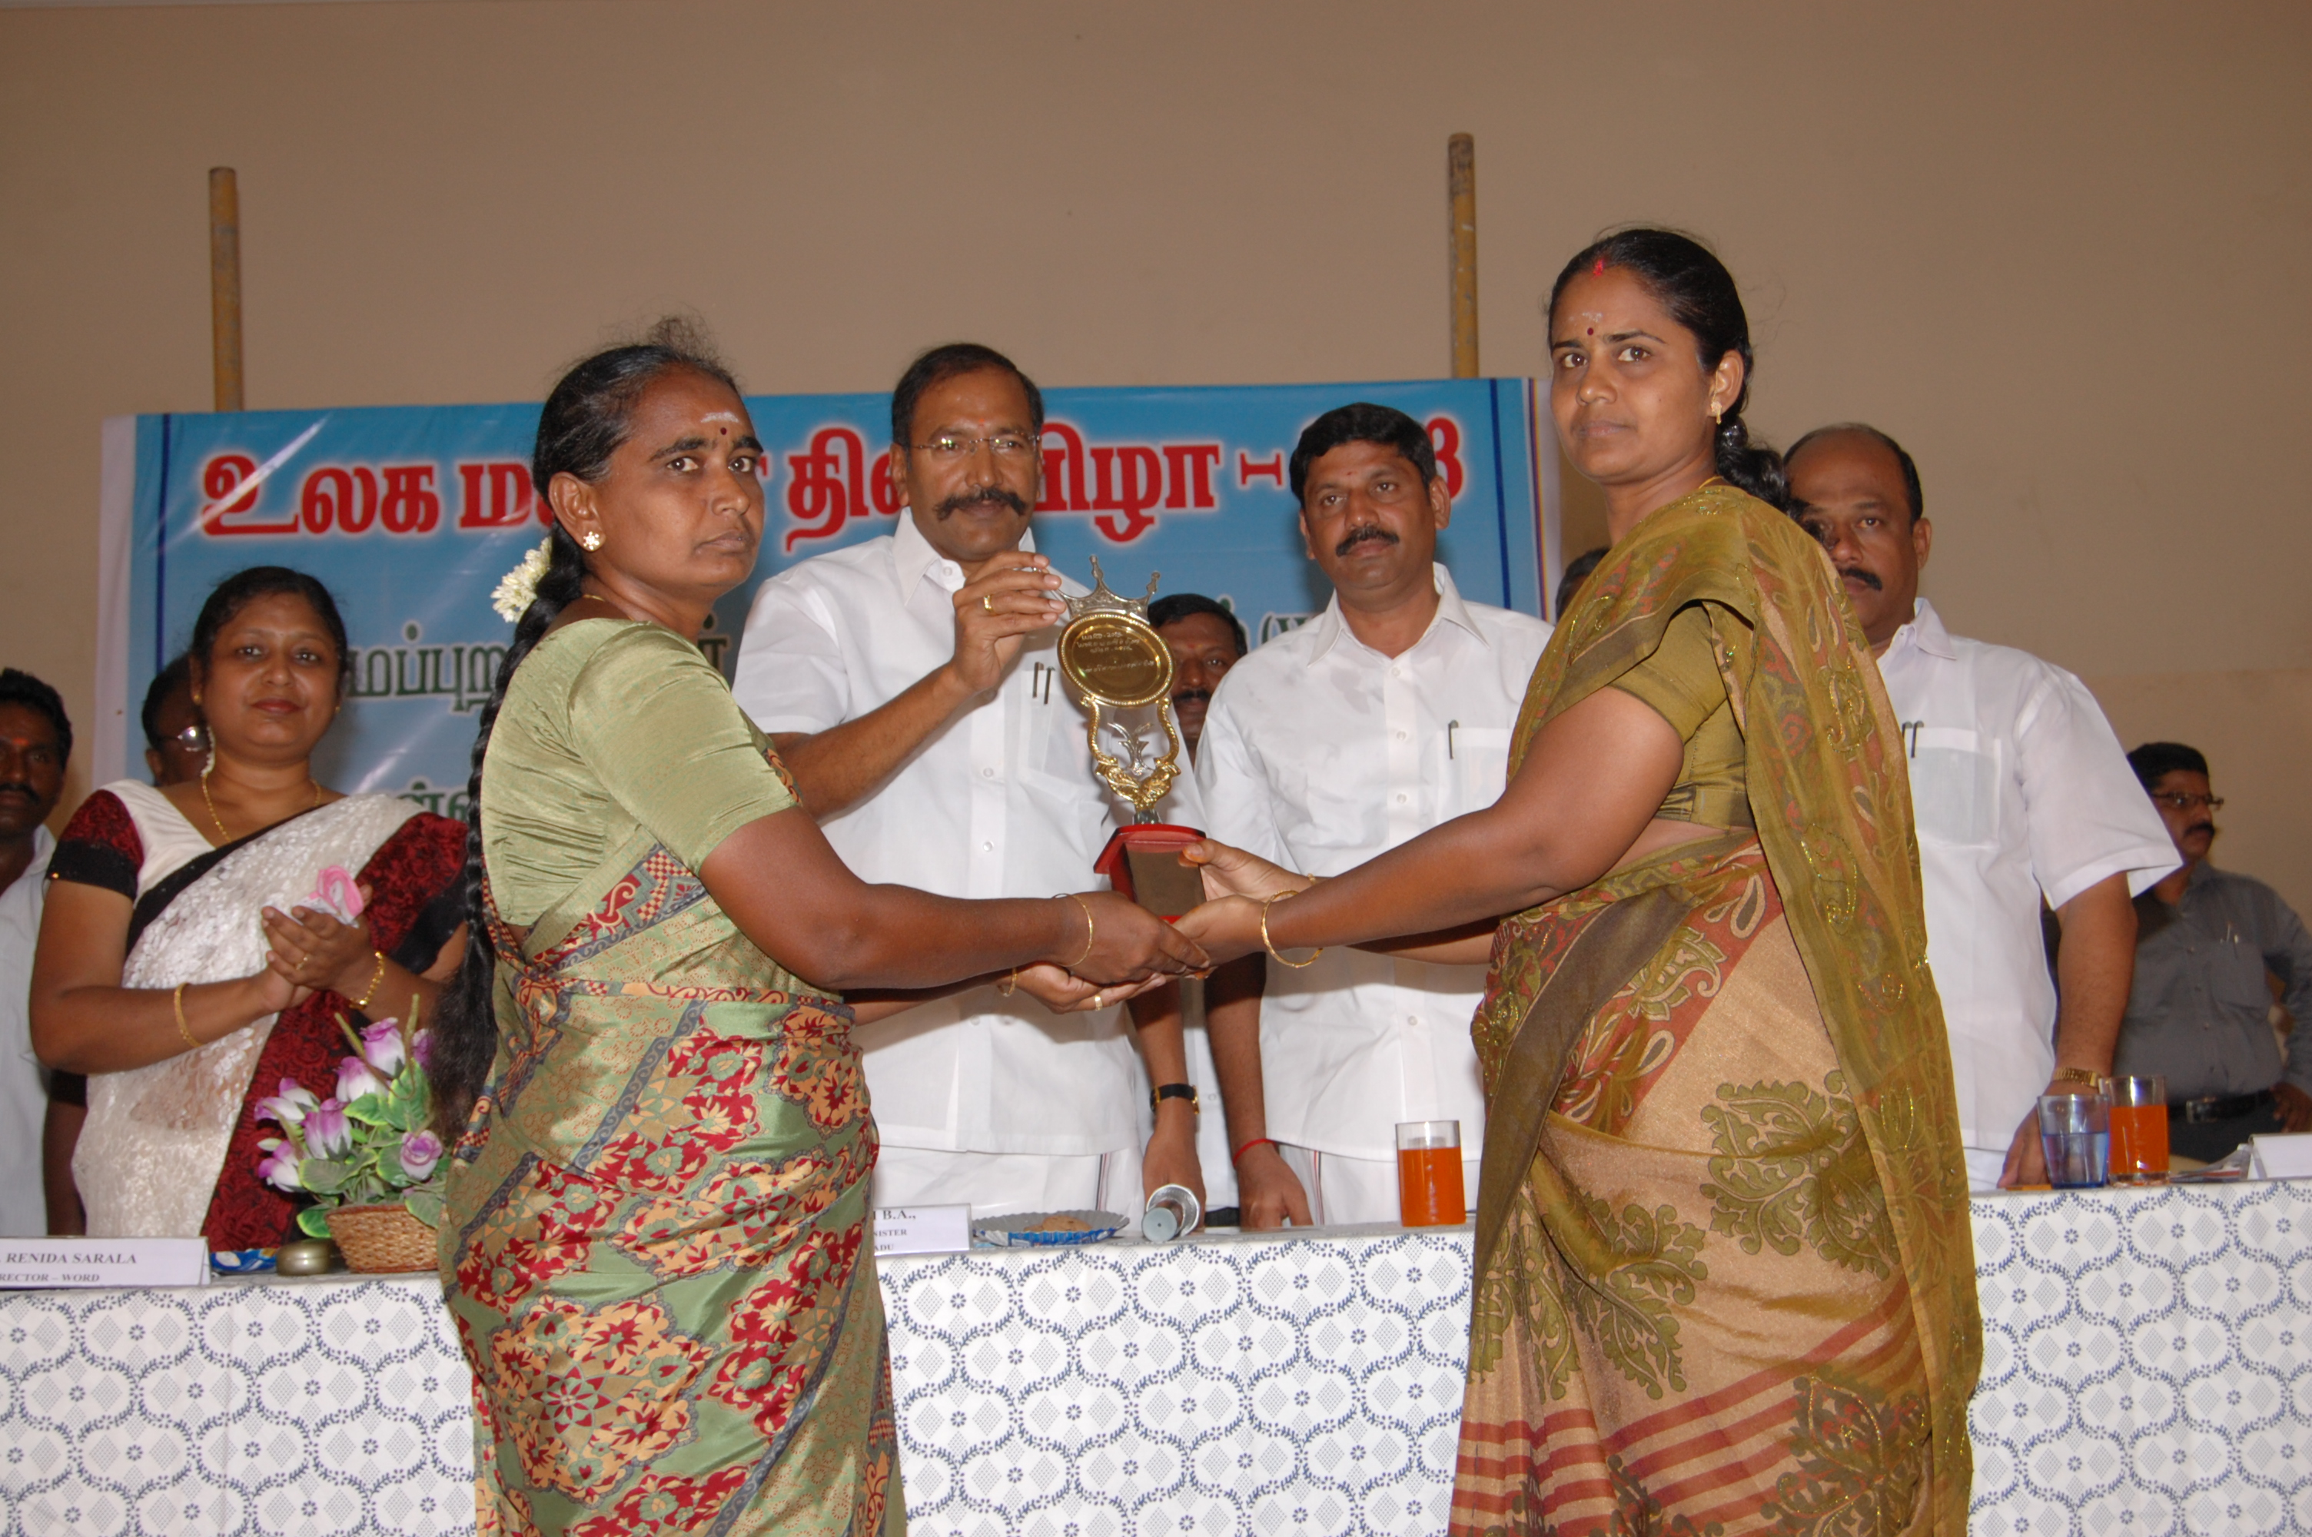

blooming buds project
stop exploitation of children

"Blooming Buds" project which aims for an overall development of children in 40 villages of Namakkal block besides the satellite support of 662 families affected by HIV/AIDS is being implemented from September 2007 with the funding support of Terre des Hommes-Netherlands. From October 2011, this project address the exploitation and abuse issues of children especially in the brick kiln, poultry and power loom industries in Namakkal district.
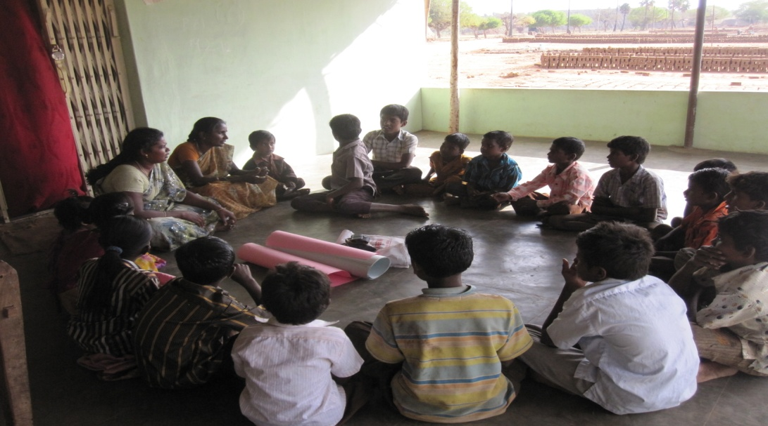 | 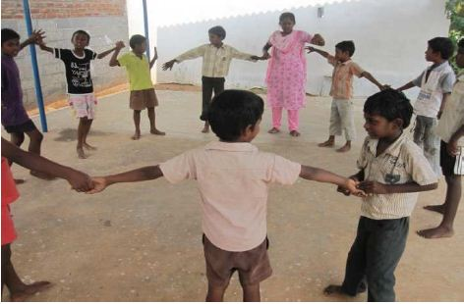
A short stay residential school for 65 children is being run by WORD in Namakkal under this project. This short stay residential Home also serves as the care and protection to the exploited children and in exploitative situations (Child Marriages, Child Labour, Wayward Children, Children in broken families) referred by the Child Welfare Committee (CWC), Child Line, Anti-human trafficking Police wing of Namakkal District for short period of time. As of March 2014, 70 rescued children from various exploitations have been provided shelter from our short stay residential home referred by CWC, Namakkal.
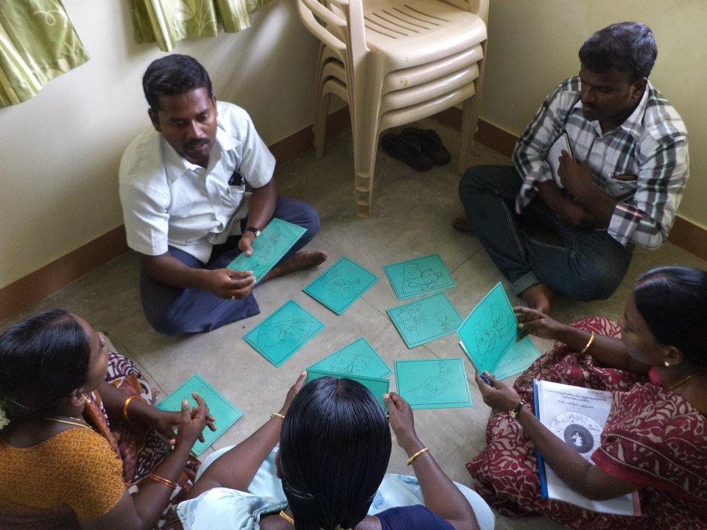 | 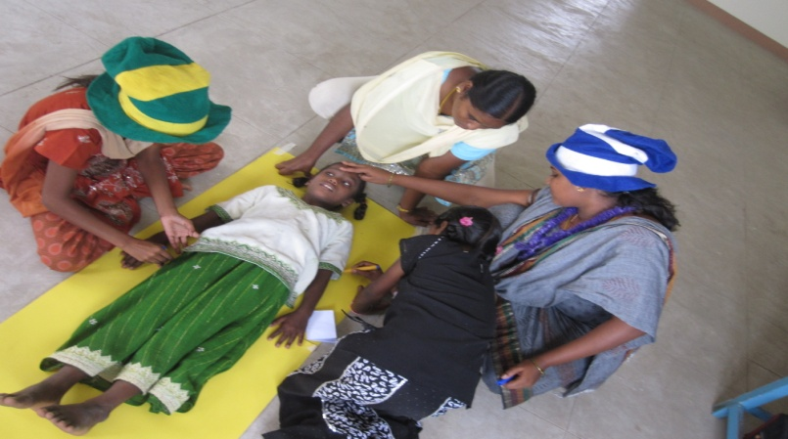
To effectively carry out this program, close co-ordination has also been established with the Integrated Child Protection Unit- Namakkal District, Childline-Namakkal, District Administration, National Child Labour Program- NCLP and Community based groups. To impart the special education for the drop outs and for the slow learners, 12 Alternative learning centres and 8 retention study centers were established in the target villages. Life skills education is being taught for the children.

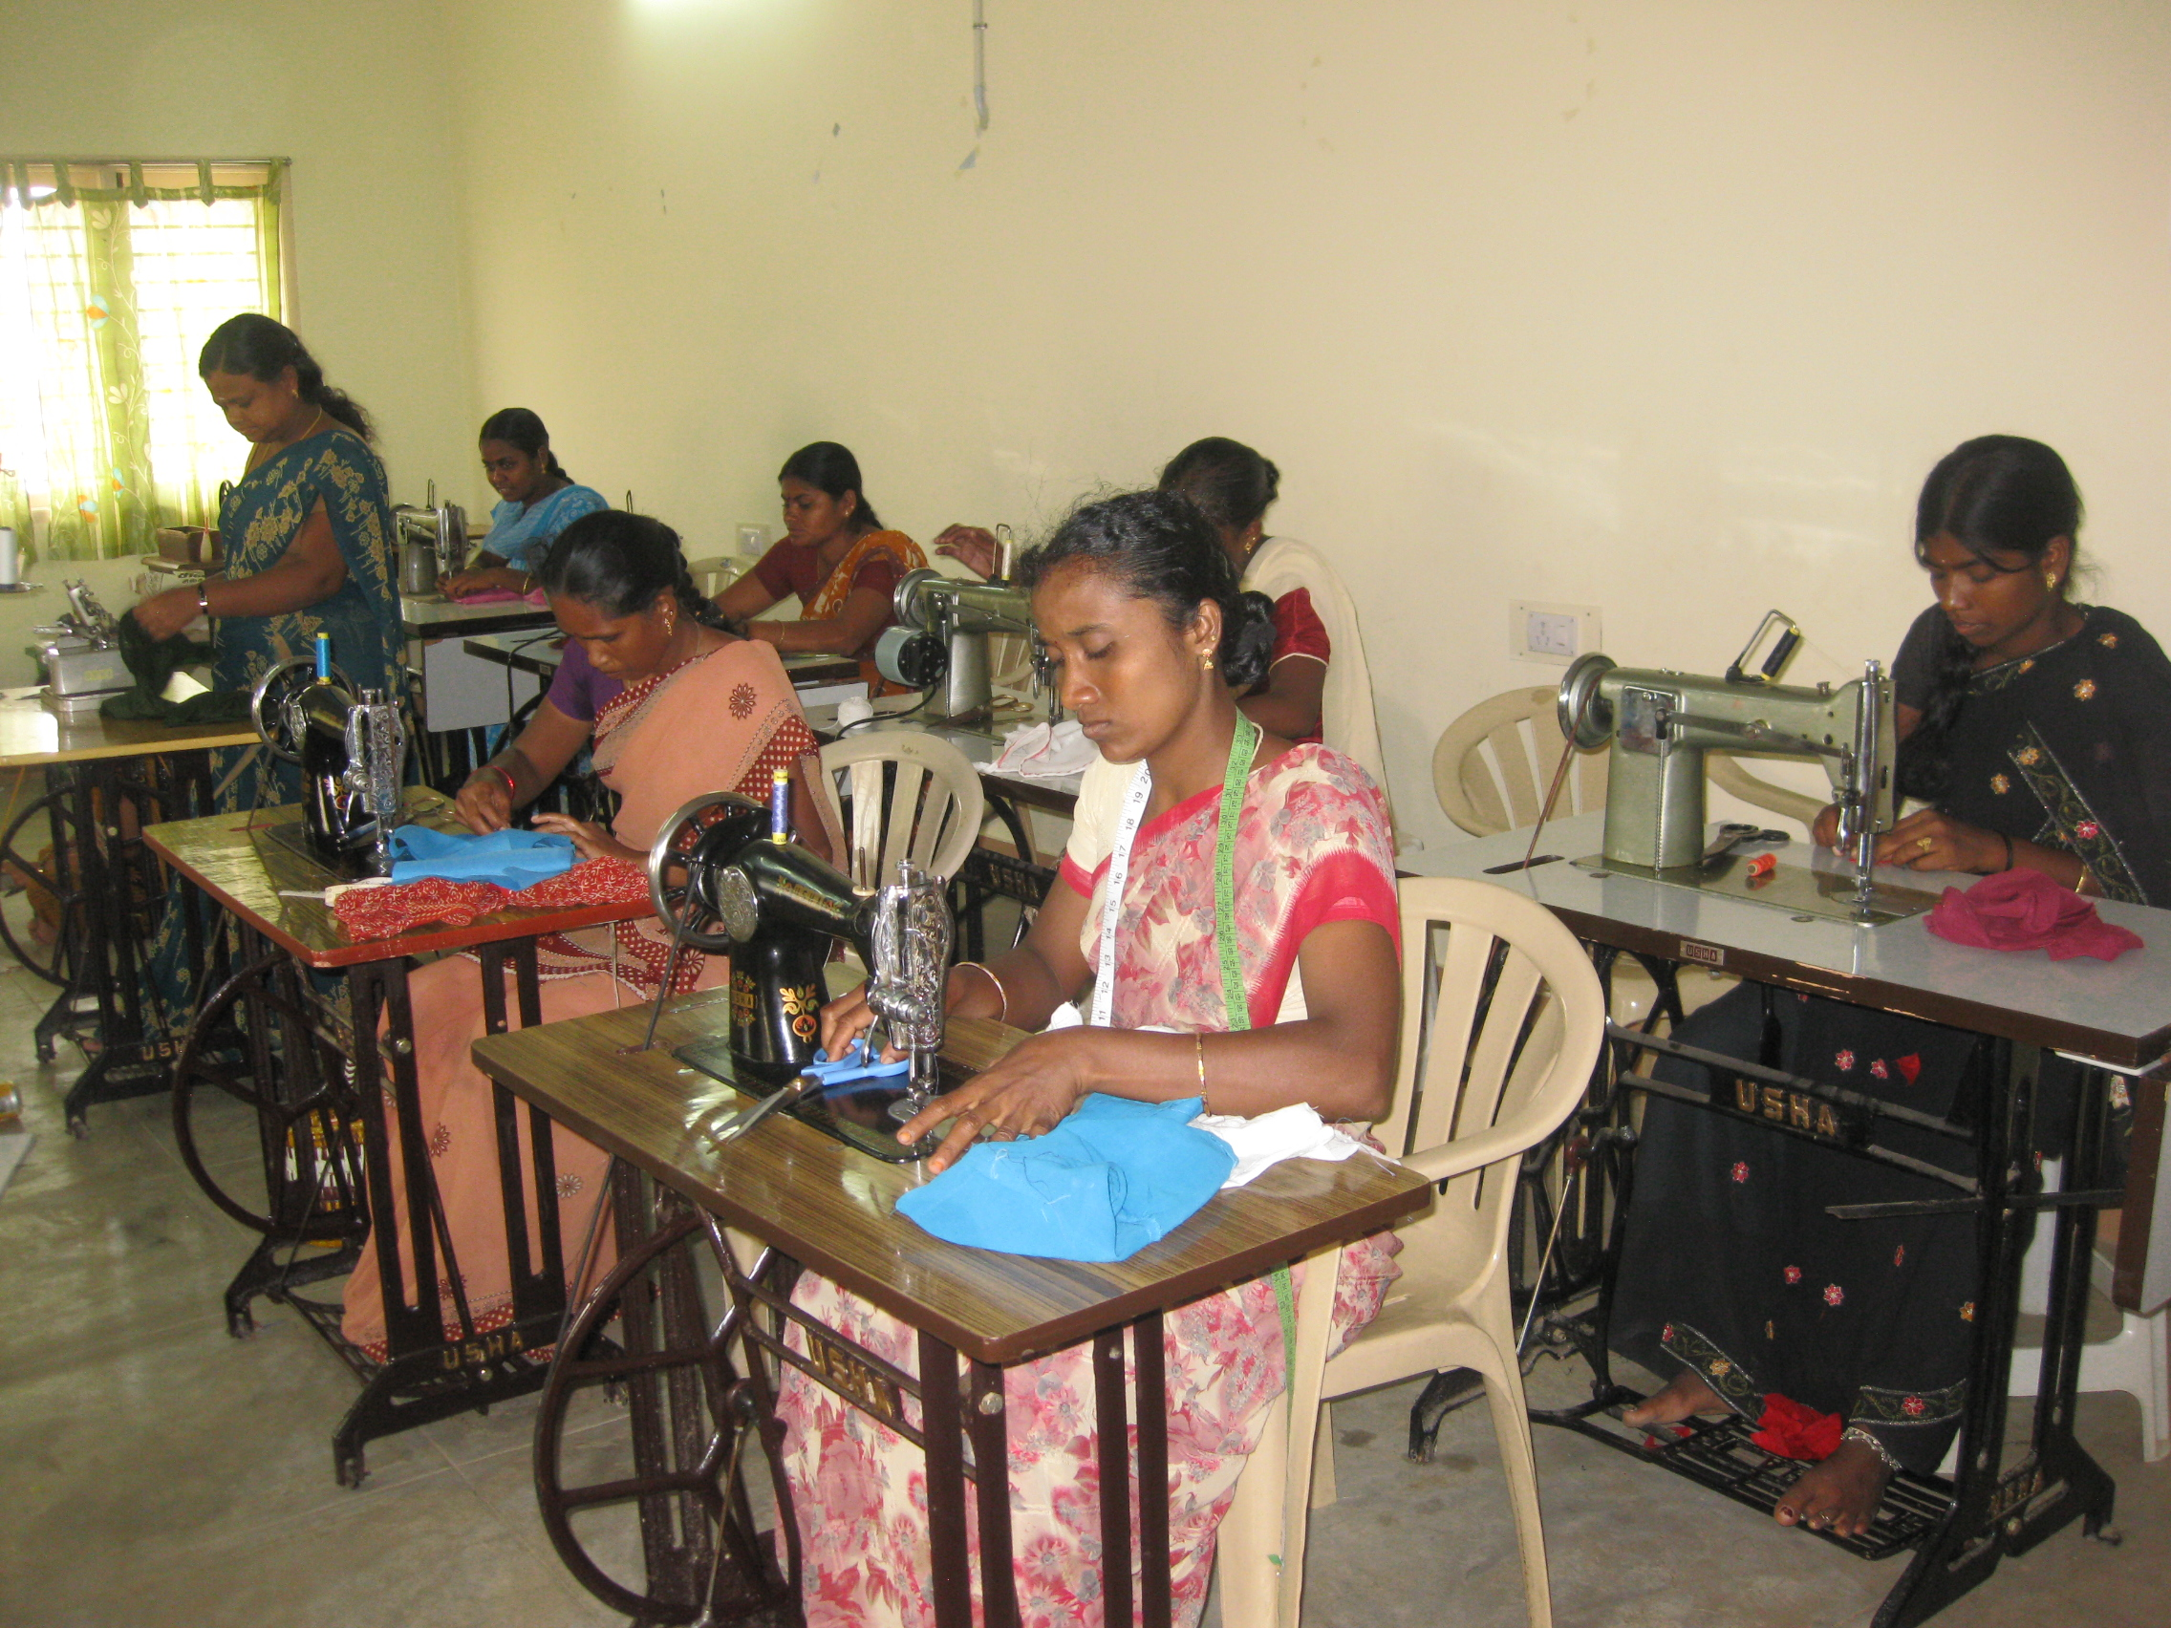 | 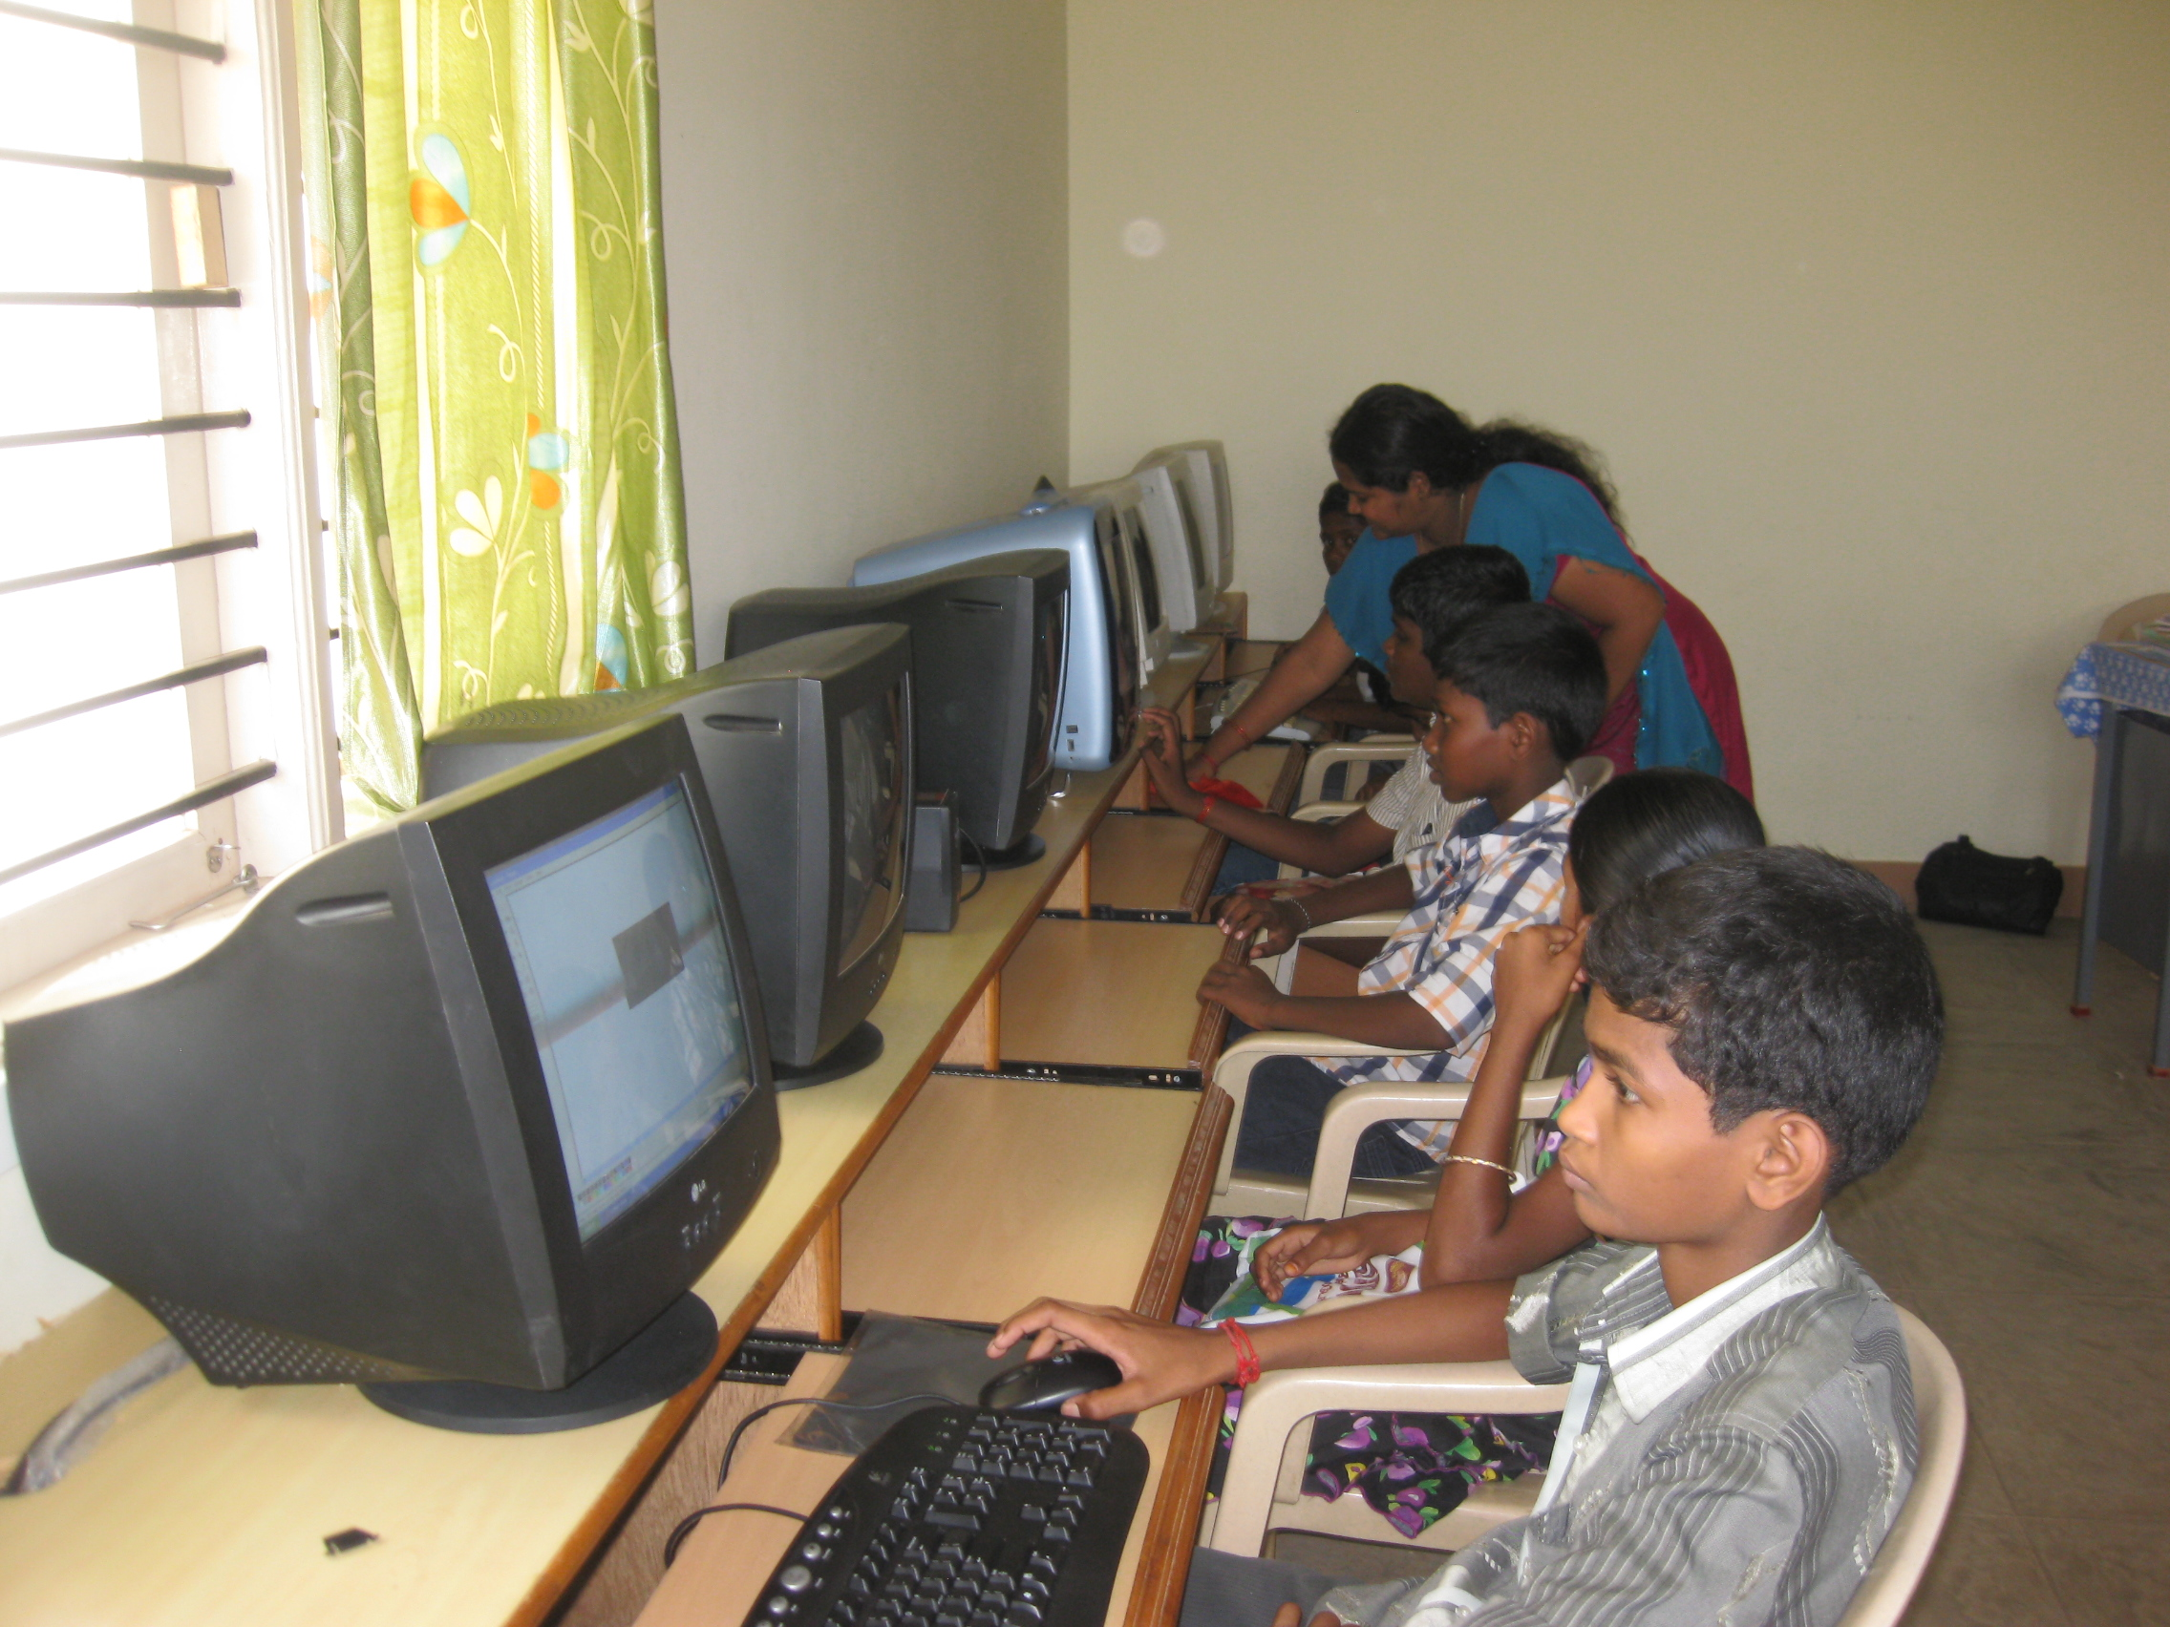
A vocational training institute in Namakkal offers training in tailoring with embroidery and computer trade at present. This vocational training institute aims to provide earning skills besides learning skills. From October 2011, a tailoring training centre started in Pallipalayam too.

Considering the importance of socio-economic development, the socially and economically deprived families are being supported with revolving fund for Relief of Poor Program.

TdHNL Revolving fund for relief of poor program

Economic independence is the core and ultimate aim in any social development initiative. Through women development Program WORD has made tremendous linkages of loan assistances for the self help groups from banks.
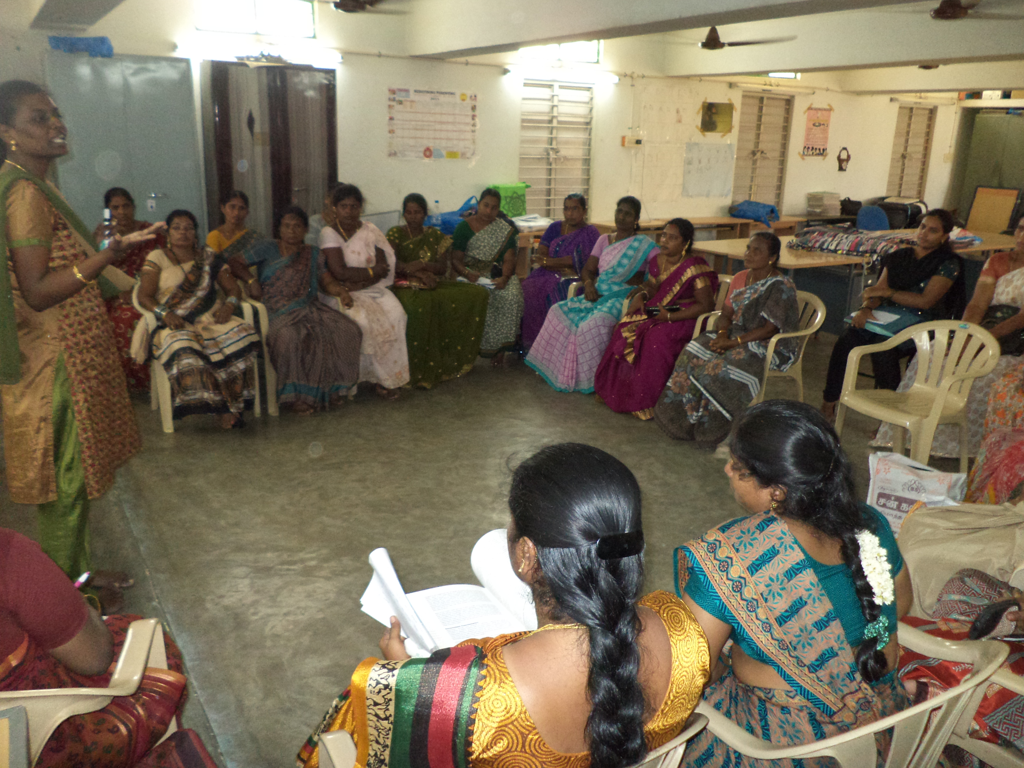 | 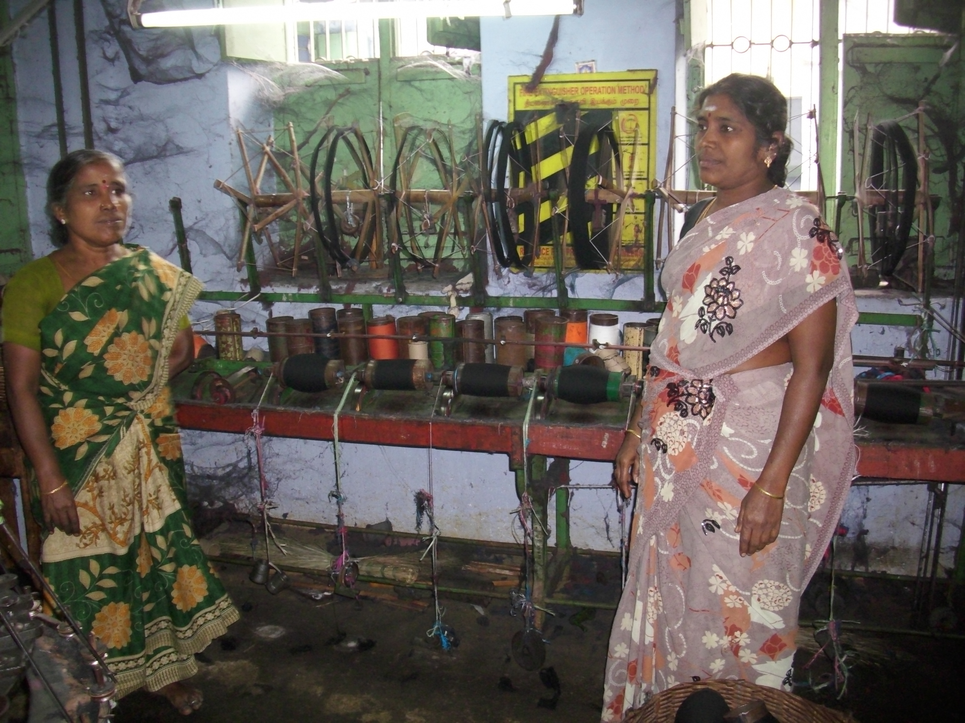

Due to the growing need for the economic development of the rural women and men in Namakkal District, WORD joined in hands with HDFC bank under business correspondent model for its micro-credit program for the self help groups. The micro credit helps the group members to start various micro-enterprises to generate considerable income for the family and to spur the rural economy. It has to be noted that WORD has already implemented the micro-credit program with the funding support of ECLOF-India, Chennai and Mrs. M. Renida Sarala, Director of WORD is presently serving as a board member in ECLOF-India office at Chennai.

WORD is disbursing micro-credit assistance for the self Help Groups with the financial support from Terre des Hommes, Netherlands and techno-managerial support from NELINDCO Foundation, Bangalore for various entrepreneurial activities of the self help groups.

The groups who have got loans from this micro-credit program have started ready-made power loom units, garment units, micro scale foot-mat making units, brick chambers, piggery unit, setting up grocery shops, hand loom units to make silk sarees etc.,

Till March 2014, an amount of Rs 5, 75, 70,406 have been disbursed to 2491 members from self help group members.

During this period, with the support of ICICI Bank as a channel partner WORD also linked SHGs for micro credit assistance to a tune of Rs 1,14,33,500 to 56 self help groups.

Ministry of Labour and Employment | special schools for child labourers

WORD is one among the four NGOs to run special schools for child labourers in Namakkal District under National Child Labour Project (NCLP), with the financial assistance from Ministry of Labour and Employment, Government of India.

The three special schools are being run in Pallipalayam and Komarapalayam areas in Namakkal District where the textile and power loom industries are concentrated more. The three schools are being run in the following areas.
1. Amman Nagar, Pallipalayam.
2. K. Olappalayam, Komarapalayam.
3. Kandipudur, Pallipalayam.
The child labourers in the special schools are provided with nutritious lunch and they have been given intensive education at par with the Tamilnadu Government Education syllabus. Apart from the educational input, the skilled teachers are teaching various skills on cultural, sports and games and fine arts.
Keeping in mind that poverty is the main cause of the child labour system in the country, the parents of the children are being motivated to form as self-help groups to generate income, build assets and move towards self-reliance. It also paved a way to spur the rural economy at the village level.
Currently 66 child labourers are studying in these three special schools from standard III- standard VIII.

scindea network activities
INTEGRATED COMMUNITY DEVELOPMENT PROJECT

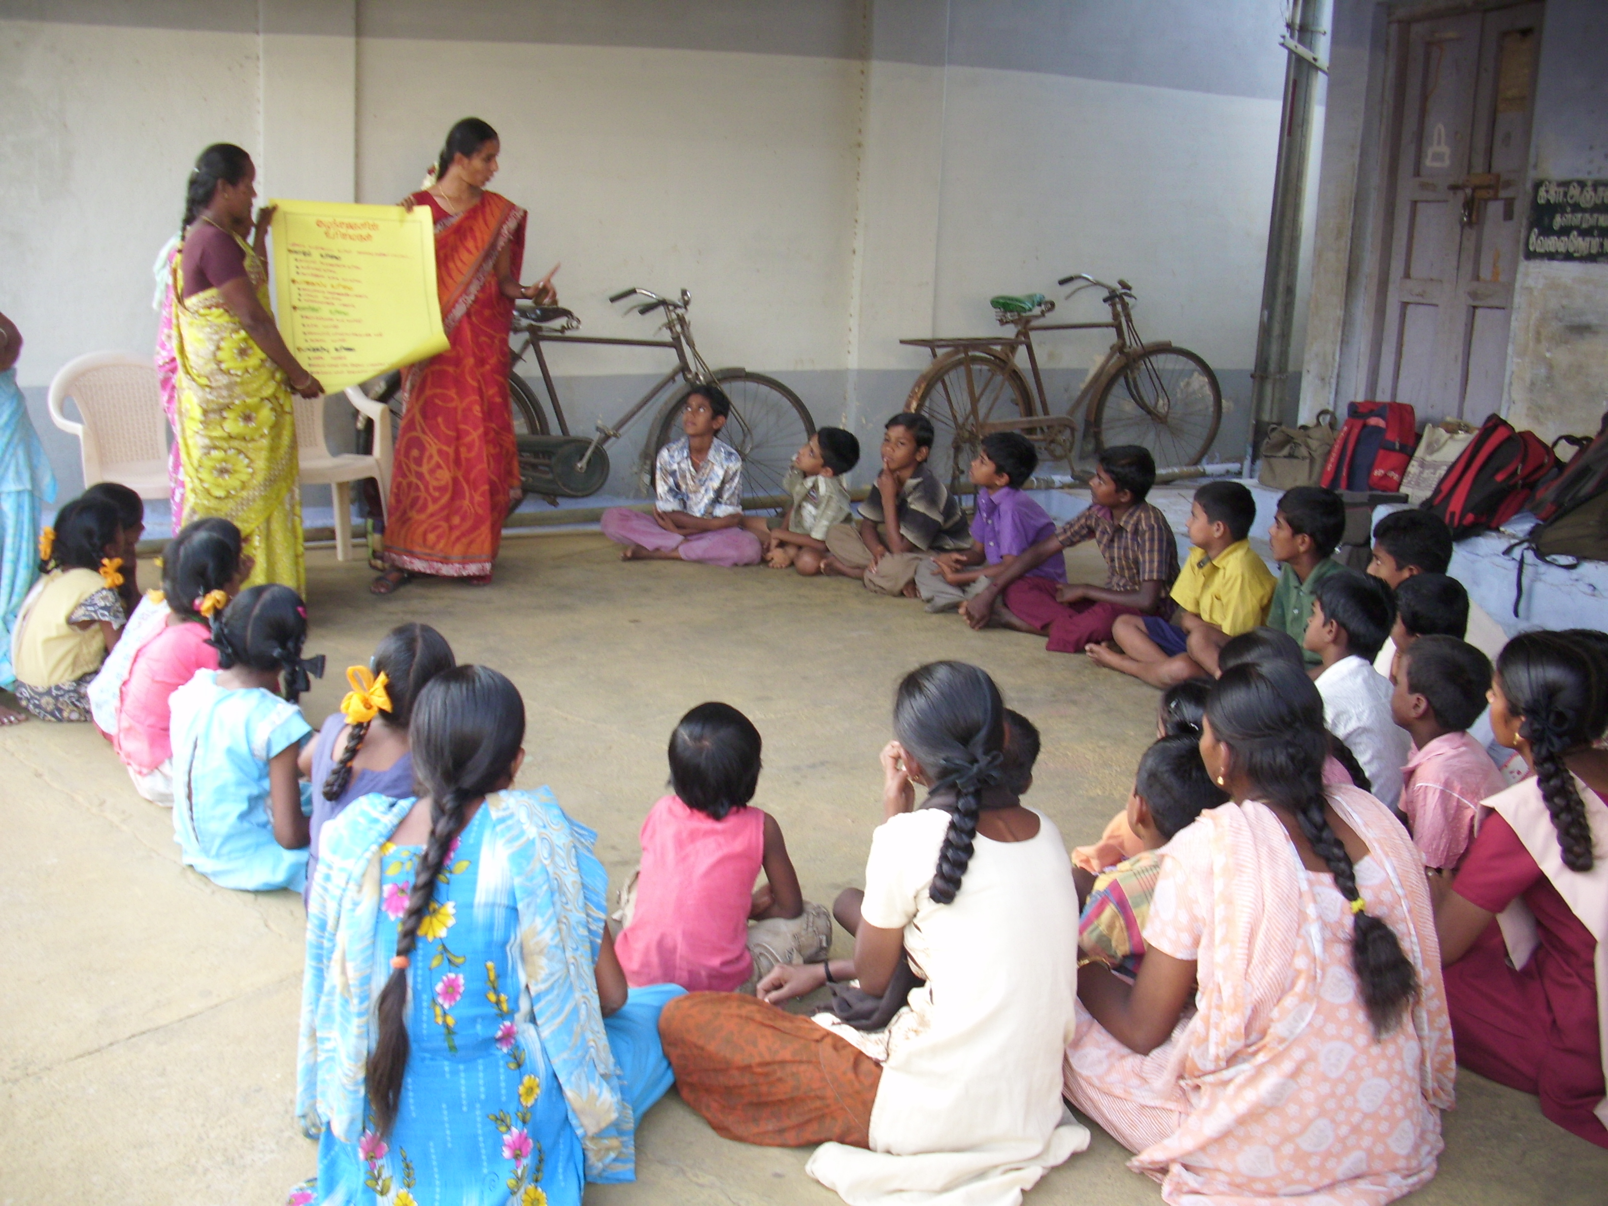 | 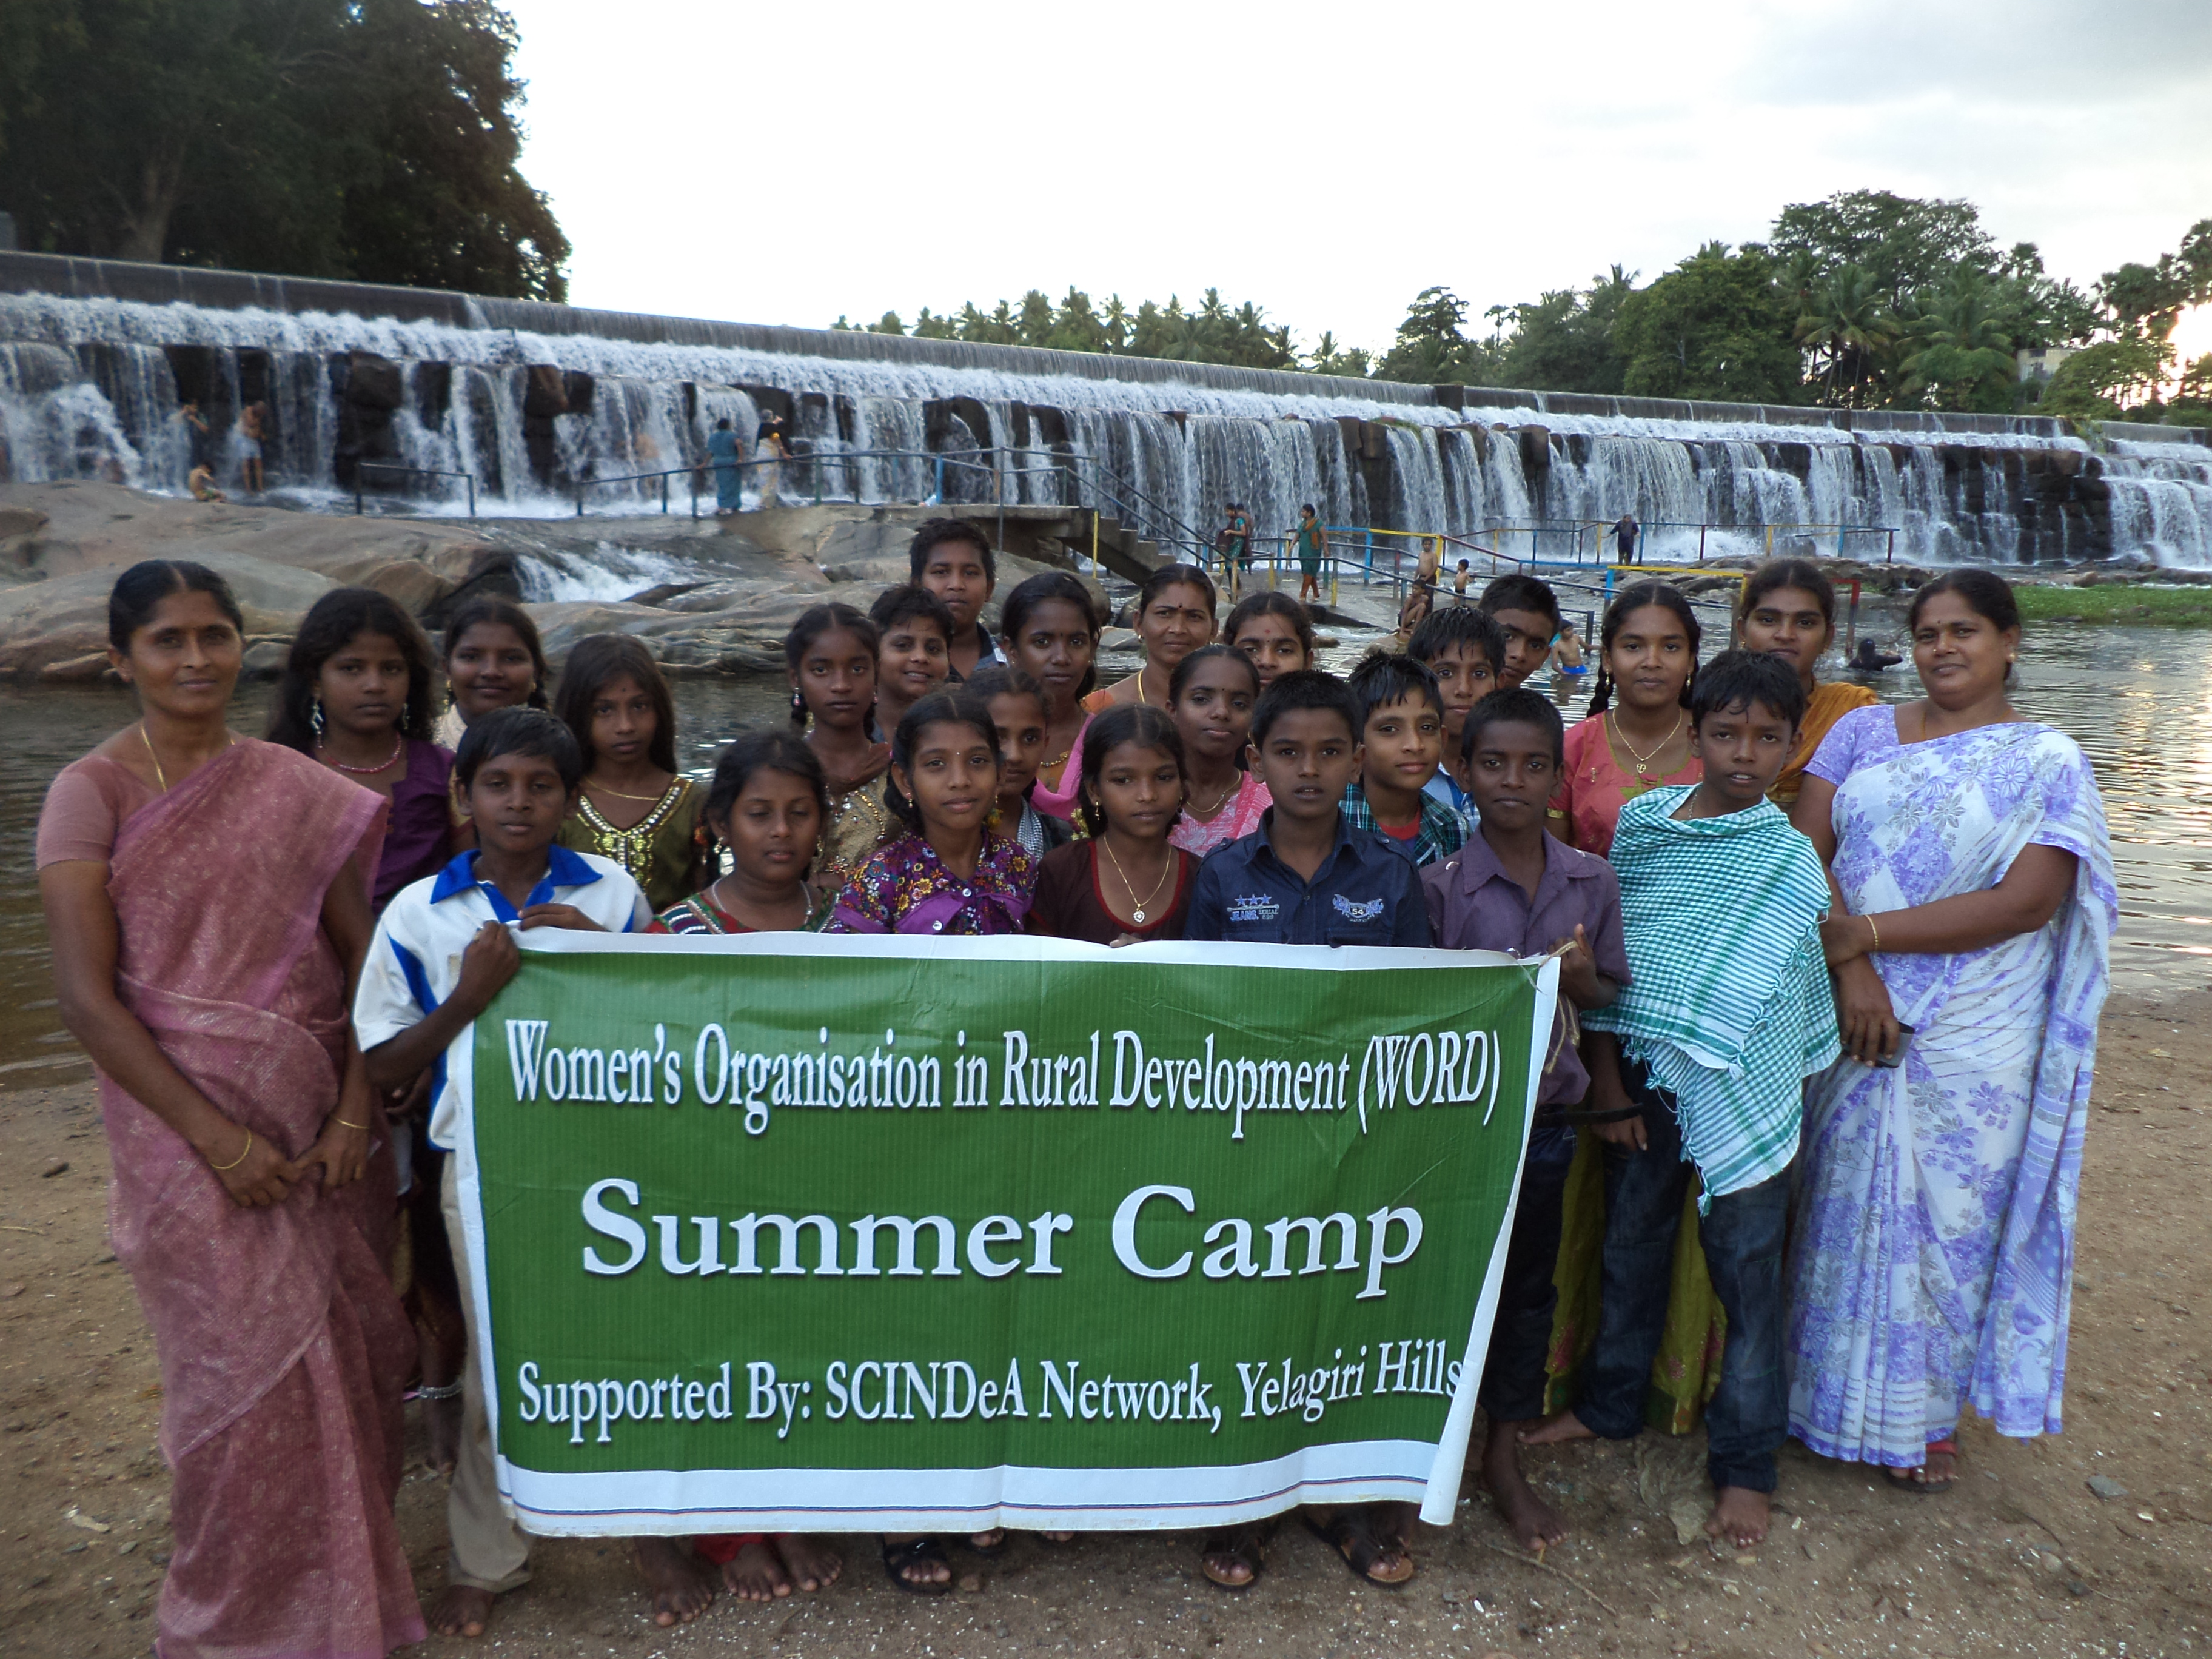

Under the South Central India Network for Development Alternatives (SCINDeA) network the Integrated Community Development Project is being implemented in 30 villages in Namakkal District with an integrated approach for the overall development of the community.

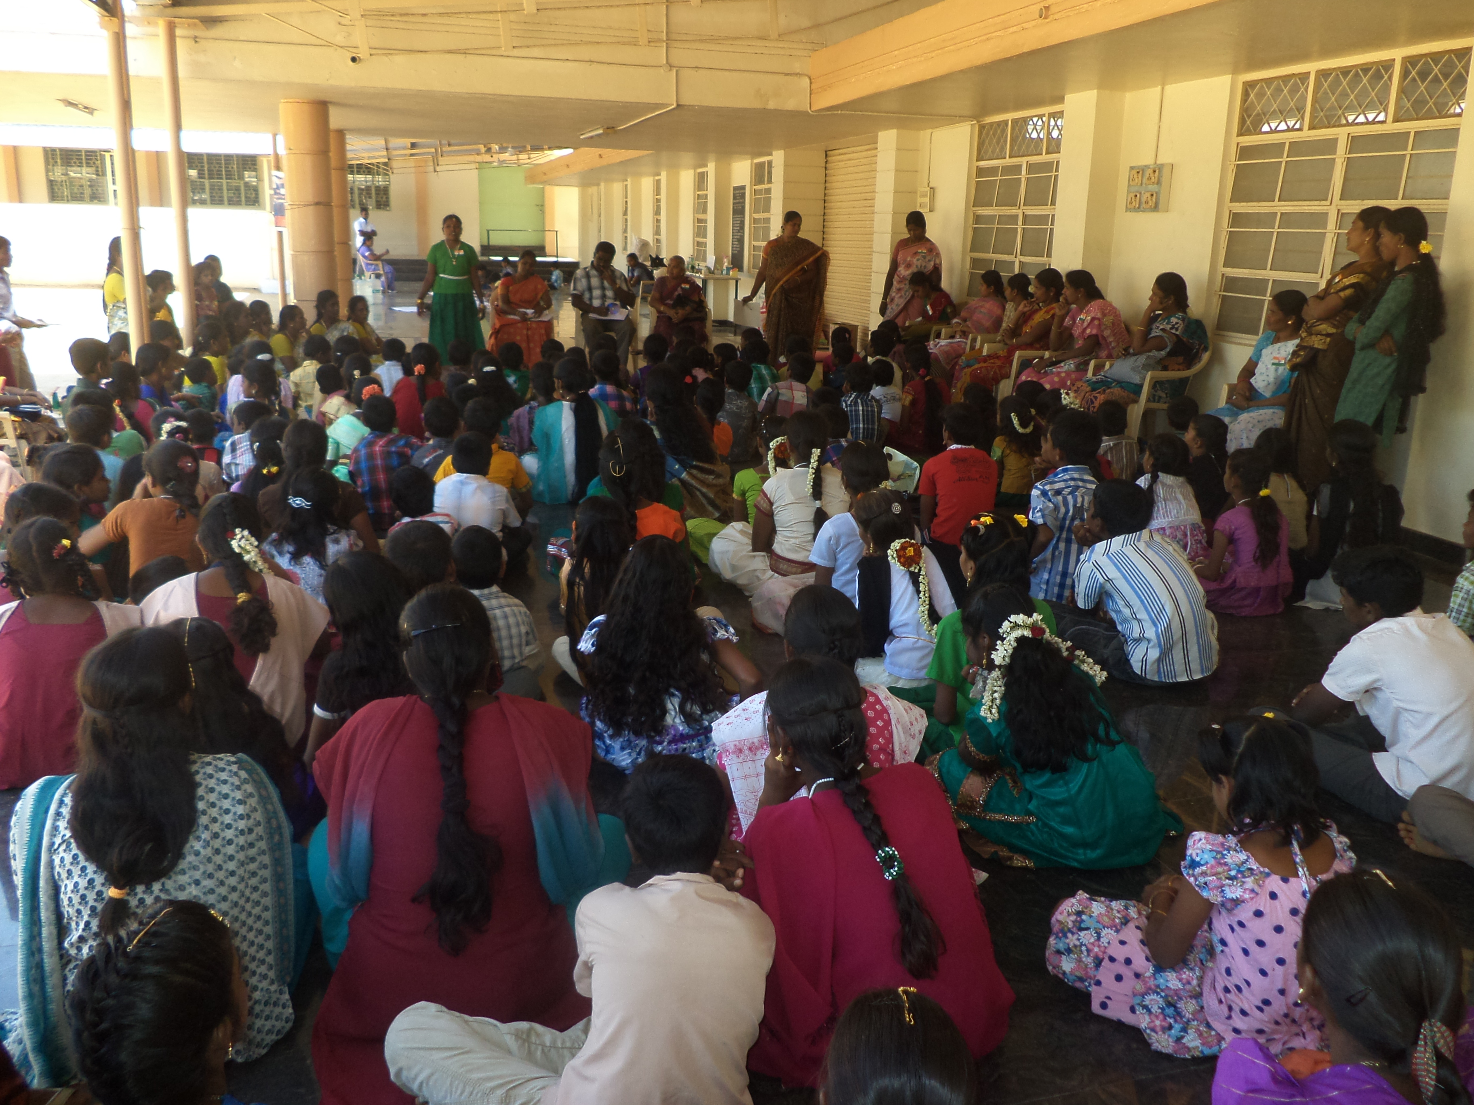 | 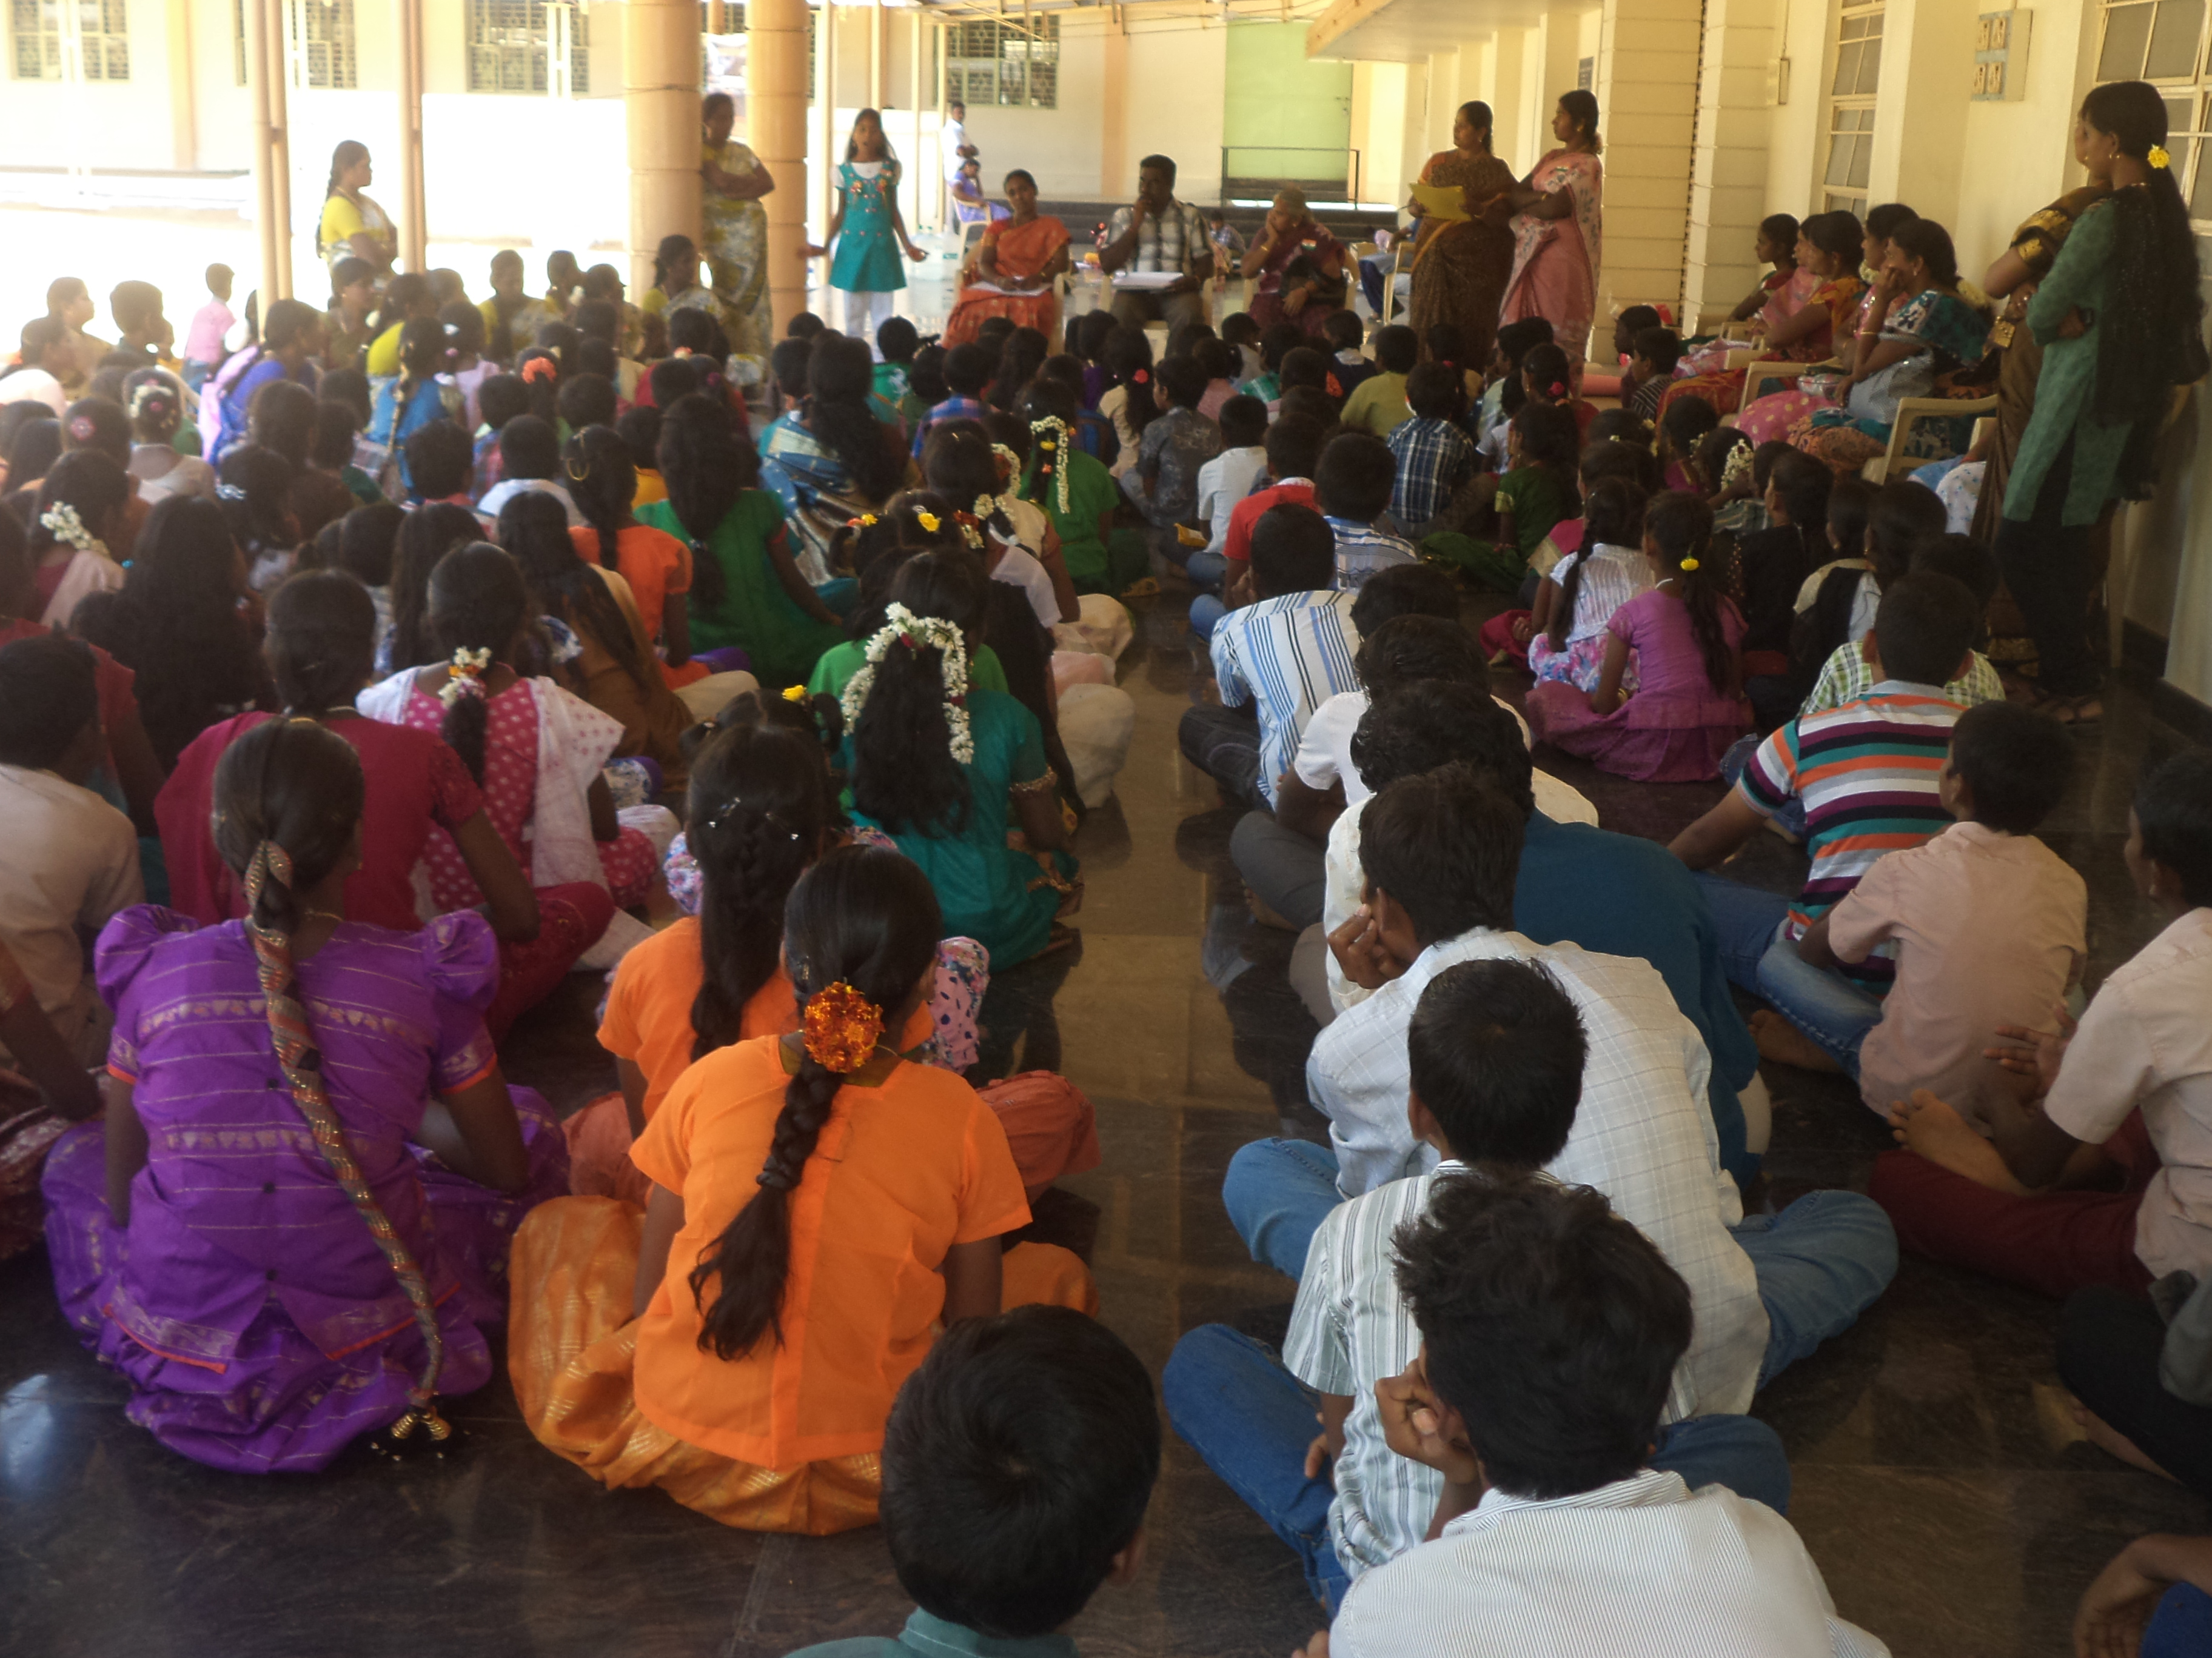

The program focuses with the wide range of integrated activities on health, education, child development, women and youth and development, sustainable environment and improved socio-economic initiatives for the families reeling under poverty through household and community based approaches.

MICRO SCALE cdm biogas project.

Micro scale cdm biogas project

WORD is one of the coalition partners of SCINDeA biogas coalition which is technically supported by Fair Climate Network. Under this project, 5000 end users will be identified and they will be built the domestic biogas units and they access the carbon revenues under Clean Development Mechanisms for their emission reductions. The pre project validations were done by TuV-Rheinland India Pvt Ltd.
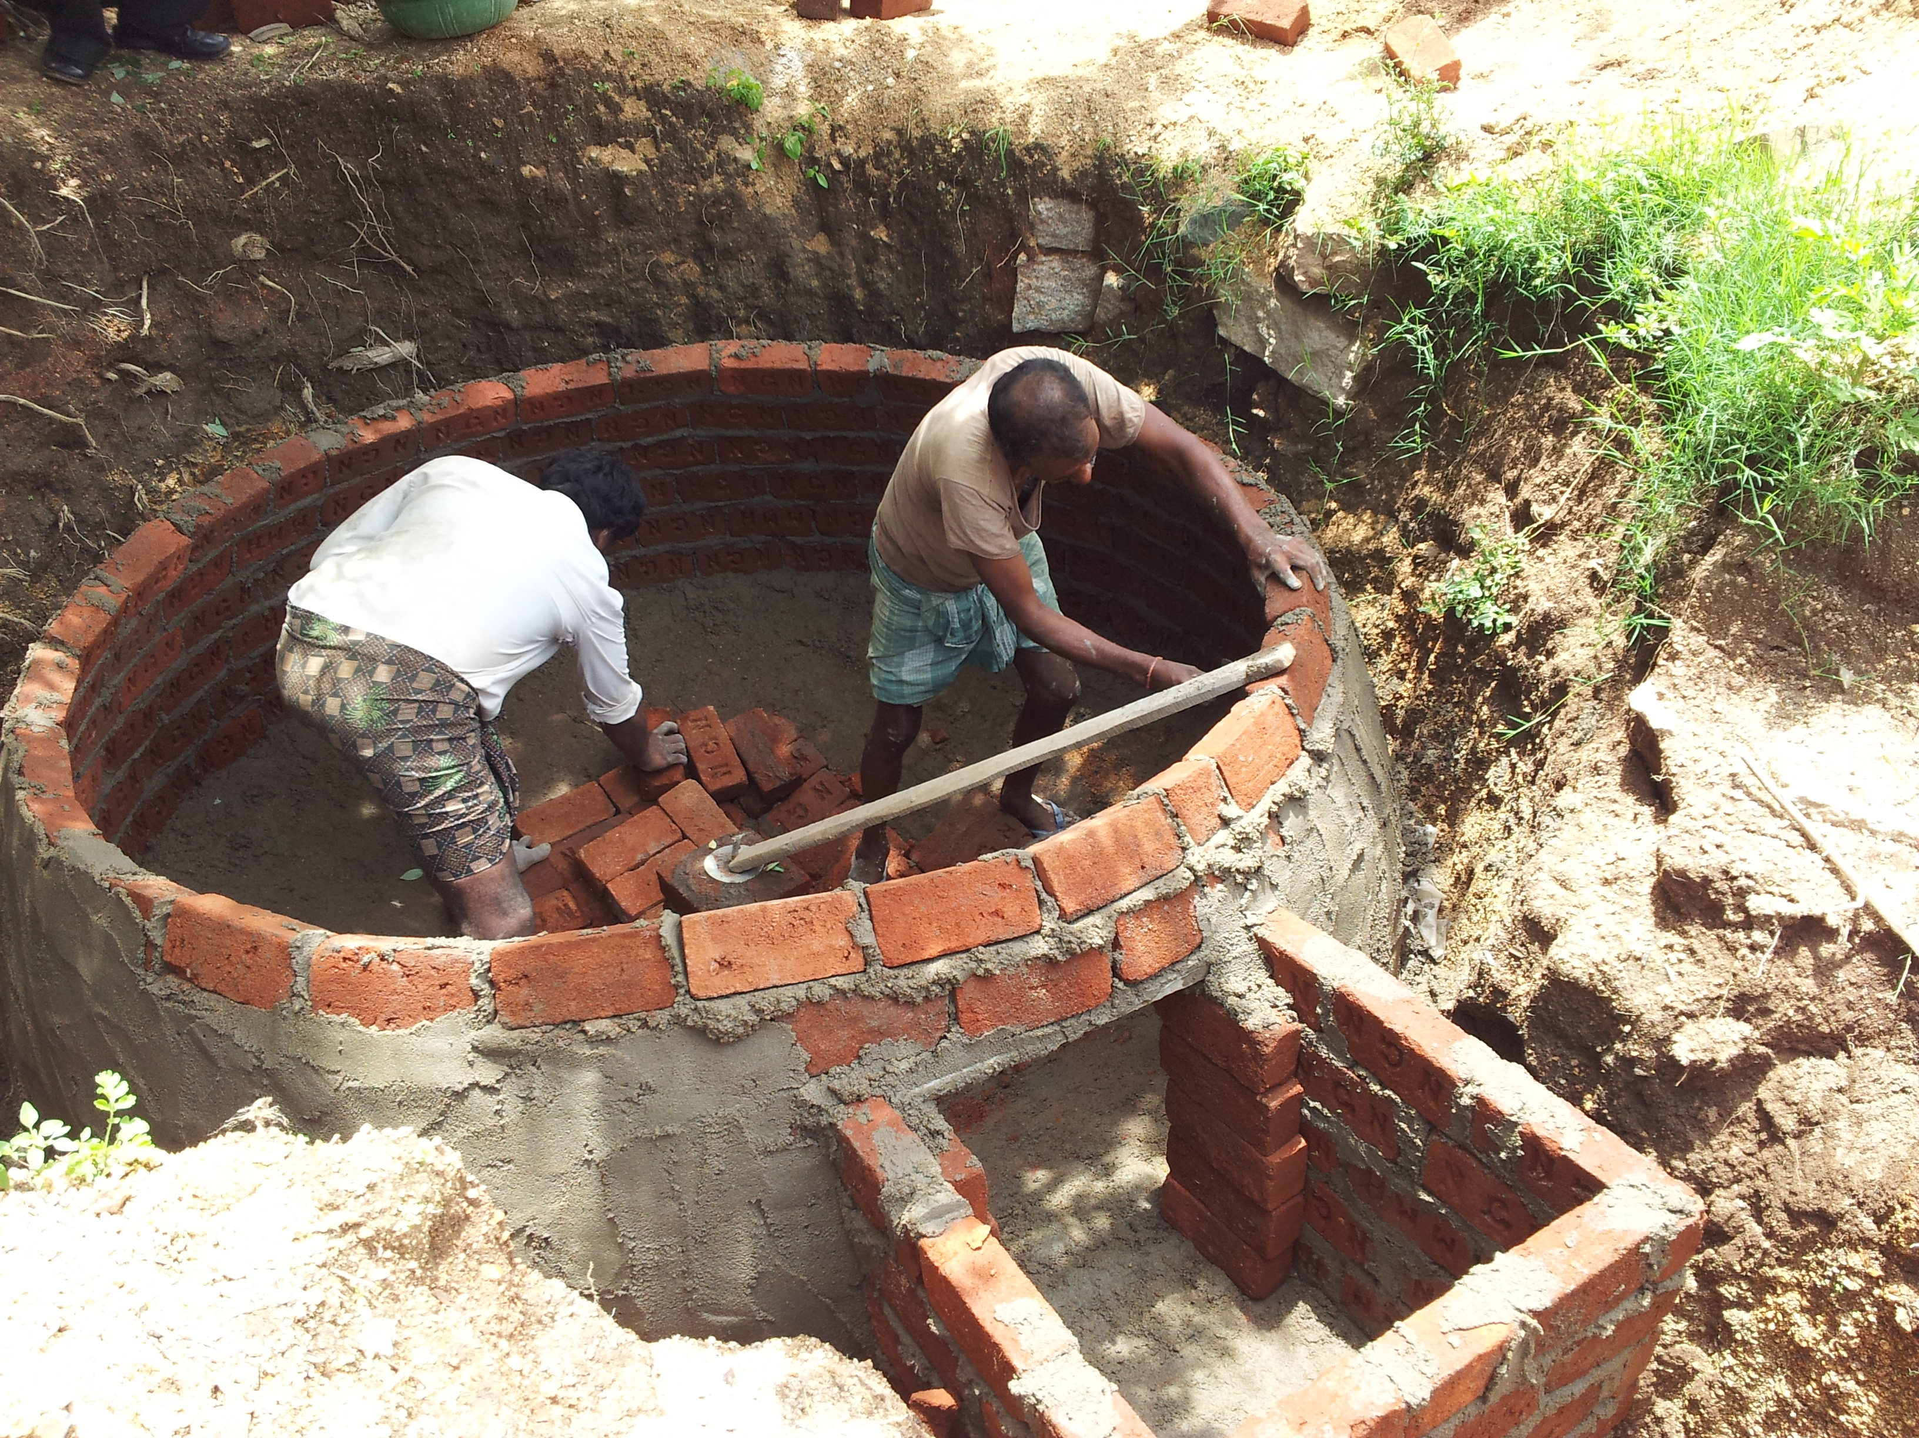 | 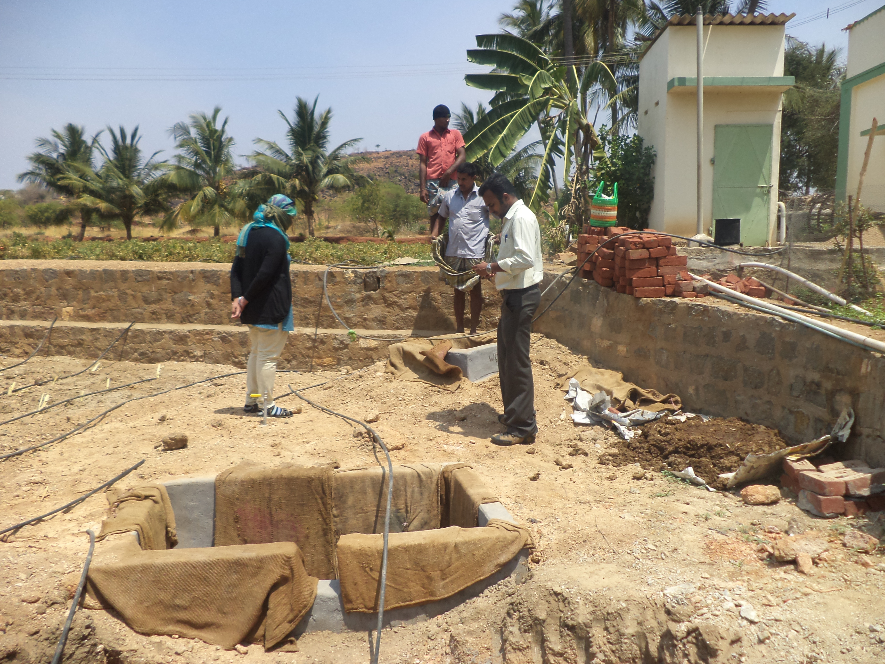

The Host Country Approval for this project has been obtained from the Ministry of Environment & Forest, Government of India. The project has been registered with UNFCCC as a microscale CDM biogas project of WORD. The project is at the stage of construction of the domestic biogas units with the selected end user families in Namakkal District.

As a pilot phase, WORD has constructed 50 biogas units in Pilikilipalayam, Kilsathambur Panchayat; Kuthanatham village in Tiruchengode Taluk in Namakkal District with the support of Fair Climate Network, Bagepalli, Karnataka.

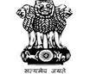  Ministry of Women and Child Development | Situational assessment of children protection in Namakkal district

With the funding assistance from Integrated Child Protection Scheme under Department of Social Defence, WORD has undertaken the study of DISTRICT NEEDS ASSESSMENT
OF CHILD PROTECTION in Namakkal during this year.

Under this program, we had discussions and meetings with various stakeholders on child protection issues, mapping of various child protection services, existing gaps in child protection services delivery and have come up with the recommendations to strengthen the services and networking for effective child protection activities in Namakkal District.

Prevention of Child Workers in Garment Industries

WORD is the implementing partner to SAVE/FIDH program in Namakkal District in implementing Community Awareness Building towards prevention of child workers in Textile Industry from March 2014.

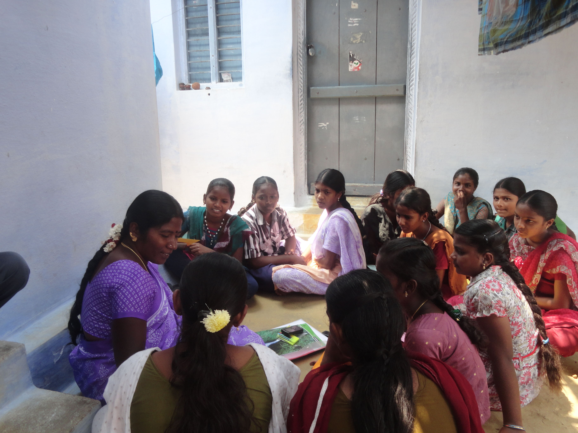 | Under this program, WORD is working in Pallipalayam, Elachipalayam and Trichengode areas to build awareness among community to prevent child workers in Textile Industries.

Branch Office

298/1 &2, Teachers Colony,
Thummankurichi Road & Post,
Namakkal. 637 003.
Phone: +91- 4286- 291 101
Email: mails@wordorg.net
Web: http://www.wordorg.net

Follow us at |  | 

